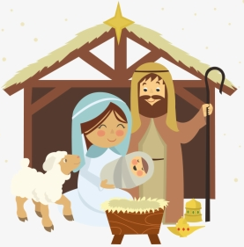

Holy Family, you’ve traveled so far. Where are you? Behind which star?

